1. Create a table comparing Agile and Waterfall models across 5 factors relevant to software testing, such as requirements, feedback cycle, tester involvement, documentation, and flexibility.
Ans:
Here is a comparison of Agile and Waterfall models from a software testing perspective:
Factor | Agile Model | Waterfall Model
1. Requirements | Requirements can evolve throughout development. Testers adapt test cases as requirements change. | Requirements are defined and documented at the beginning. Changes later are usually difficult and costly.
2. Feedback Cycle | Frequent feedback is received through short iterations/sprints, allowing defects to be identified early. | Feedback generally comes after a development phase is completed, so defects may be found later.
3. Tester Involvement | Testers are involved throughout the development process, often from the beginning of each sprint. | Testers typically become heavily involved after the development phase is completed.
4. Documentation | Documentation is maintained but generally focuses on what is necessary; working software is prioritized. | Extensive documentation is prepared for requirements, design, testing, and other phases.
5. Flexibility | Highly flexible; changes can be incorporated into upcoming sprints. | Less flexible; changes after requirements are finalized can require significant rework.
Summary
- Agile: Testing is continuous, collaborative, and adaptable.
- Waterfall: Testing is more sequential and structured, with testing typically occurring after development.

2. Pick any app you use daily (like Instagram, Zomato, or Paytm) and describe how the testing process would look different if the team used Agile instead of Waterfall. Mention at least 3 specific testing activities or practices that would change.
Ans:
Let’s take Zomato as an example. The testing process would be quite different if the team followed Agile instead of Waterfall.
Testing Activity / Practice | Waterfall testing | Agile testing
1. Test Planning | A detailed test plan is usually prepared after requirements and development are completed. | Test planning happens continuously, often at the start of each sprint. Testers prepare scenarios for features such as restaurant search or order placement.
2. Functional Testing | Testers test the complete feature after the development phase. For example, the entire food-ordering flow may be tested after development is finished. | Features are tested incrementally. For example, restaurant search might be tested in one sprint, cart functionality in another, and payment in another.
3. Regression Testing | Regression testing is generally performed toward the end of the project or after major changes. | Regression testing is performed frequently, often using automated tests, to ensure new sprint changes do not break existing features.
4. Defect Handling | Bugs found during the testing phase are documented and sent back to developers for fixing, potentially causing delays. | Developers and testers work together throughout the sprint. Bugs can be discussed and fixed quickly within the same iteration when possible.
5. Customer Feedback | Customer feedback may arrive relatively late, after a working version is delivered. | Feedback is collected frequently after sprint releases, allowing the team to modify upcoming features and tests.
Example
Suppose Zomato is introducing a “Schedule Your Order” feature:
- Waterfall: Requirements → Design → Development → Testing → Release. Testing mainly happens after development is complete.
- Agile: The feature is divided into smaller stories. Testers test each story during the sprint, automate important regression cases, report defects immediately, and incorporate user feedback into the next sprint.
In short: Agile makes testing continuous, collaborative, and iterative, while Waterfall makes testing more sequential and phase-based

3. Draw a simple workflow diagram showing the main roles (such as Scrum Master, Product Owner, Development Team, Tester) and ceremonies (like Sprint Planning, Daily Standup, Sprint Review) in a SCRUM process.
Ans:
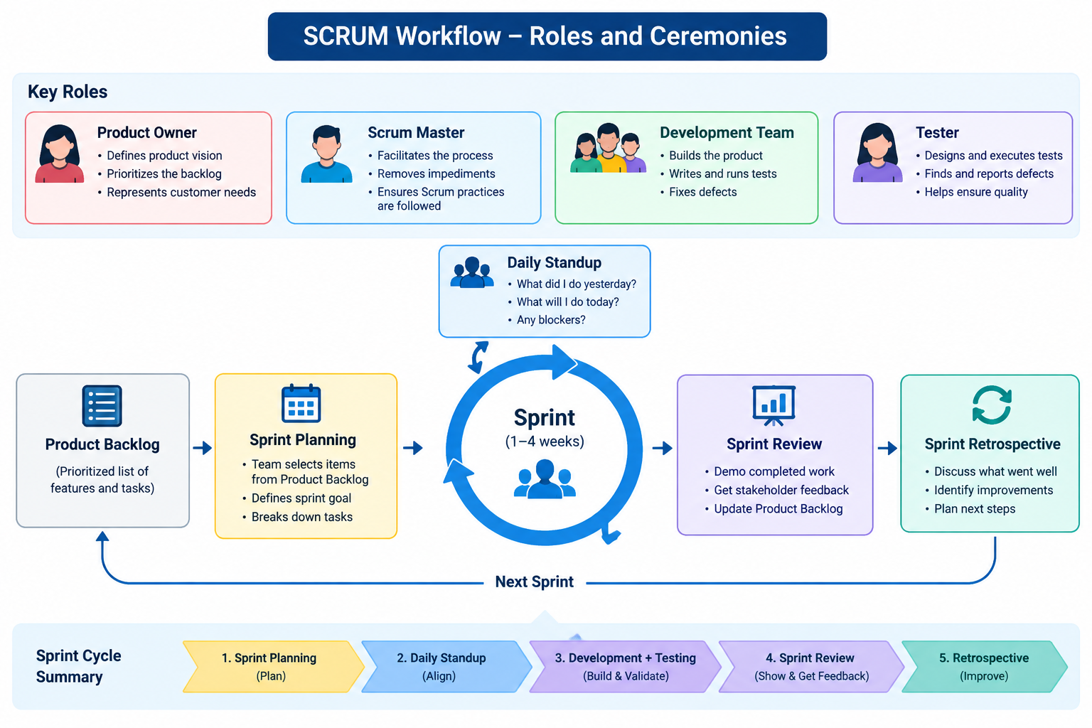
SCRUM ROLES
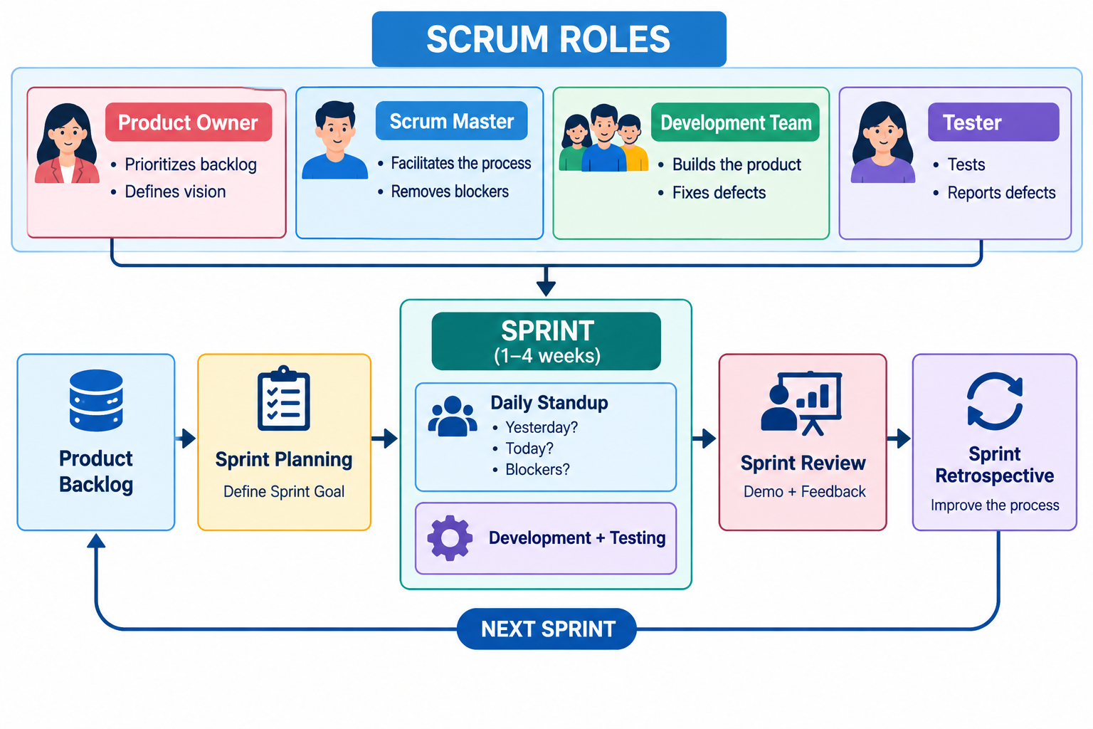
Flow: Product Backlog → Sprint Planning → Sprint → Daily Standups + Development/Testing → Sprint Review → Retrospective → Next Sprint.

4. For a food delivery app (like Swiggy), map out which testing activities should happen during each phase of a typical Agile sprint (e.g., backlog grooming, sprint planning, development, review).<br><br><em><strong>Hint:</strong> Include activities like writing user stories, test case design, test execution, and bug reporting.</em>
Ans:
Agile Sprint Testing Activities for a Food Delivery App
Agile Sprint Phase | Testing Activities | Example for Swiggy-like App
1. Backlog Grooming / Refinement | Write and clarify user stories, identify acceptance criteria, estimate testing effort, and identify risks/dependencies. | User story: “As a customer, I want to apply a coupon before placing my order.” QA clarifies rules such as valid coupon, expiry, minimum order value, and usage limit.
2. Sprint Planning | Review acceptance criteria, identify test scenarios, decide test data/environment needs, and plan testing tasks. | QA prepares scenarios for successful coupon application, invalid coupon, expired coupon, and minimum-order failure.
3. Development / Coding | Perform test case design, review requirements, prepare test data, and create automation scripts where appropriate. QA also works with developers to clarify defects early. | Create detailed test cases for restaurant search, cart calculation, coupon validation, and order placement.
4. Build / Continuous Integration | Run unit tests, API tests, smoke tests, and automated regression tests on new builds. | Check that adding an item to the cart does not break price calculation or restaurant availability APIs.
5. Test Execution | Execute functional, integration, UI, and regression tests. Record actual results and collect evidence for failures. | Test the complete flow: login → select restaurant → add food → apply coupon → choose address → payment.
6. Bug Reporting & Retesting | Log defects with clear steps, expected vs. actual results, severity/priority, screenshots or logs, then retest fixes. | Report: “Coupon shows ‘Applied’ but the order total remains unchanged.” After the developer fixes it, QA retests the scenario.
7. Sprint Review / Demo | Validate completed stories against acceptance criteria and demonstrate tested functionality. QA confirms whether stories meet the Definition of Done. | Demonstrate successful food ordering with coupon, correct bill calculation, and order confirmation.
8. Sprint Retrospective | Review testing problems, escaped defects, automation gaps, and process improvements. | Team decides to add automated tests for coupon edge cases because similar bugs were found repeatedly.

Simple Agile Testing Flow
Backlog Grooming → Sprint Planning → Test Design → Development + Continuous Testing → Test Execution → Bug Reporting → Retesting/Regression → Sprint Review → Retrospective

